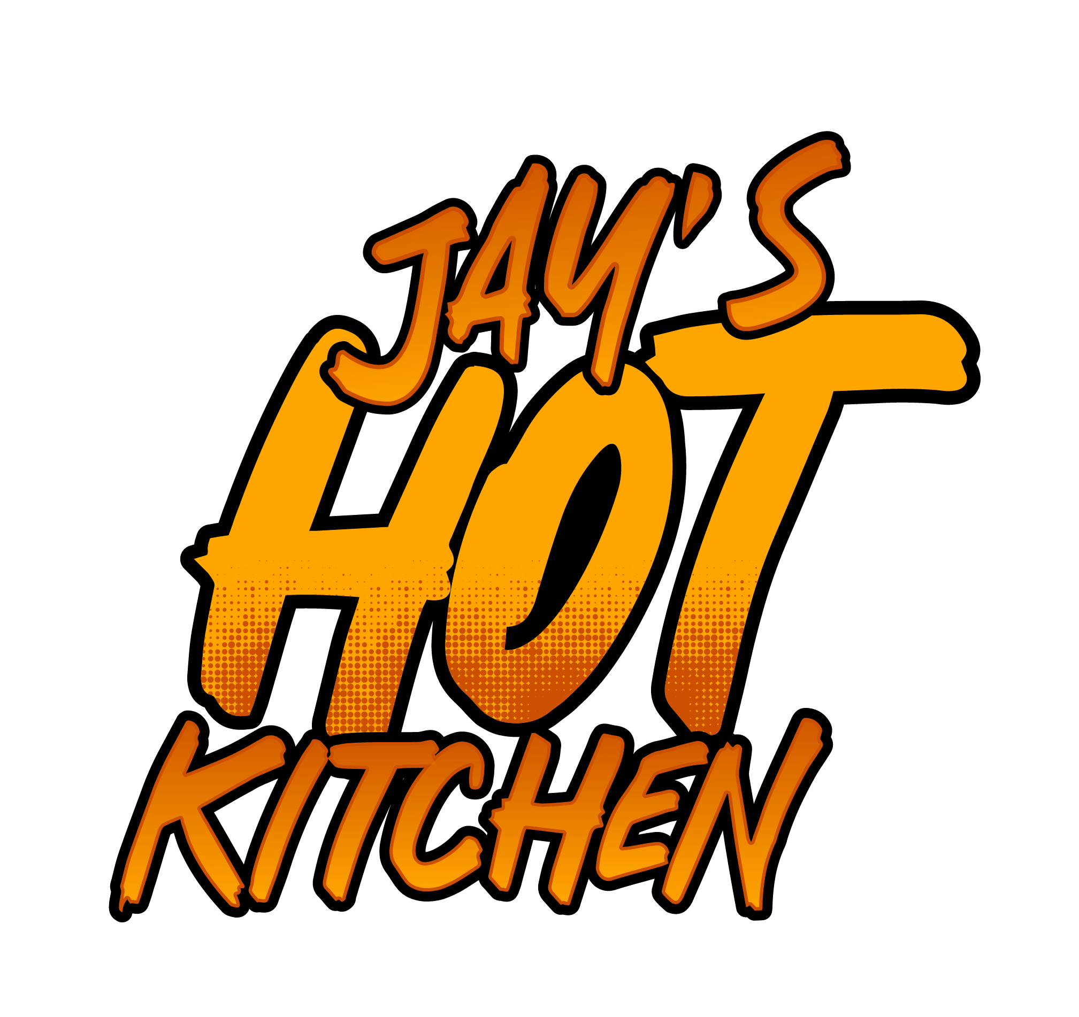
Fried Chicken Sandwich
Choice of BBQ, Buffalo or Sweet Heat
Fried Chicken Breast, Lettuce, Tomatoes, Mayonnaise and Pickles on a Brioche Bun
Nashville Chicken Sandwich
Fried Chicken Breast dipped in Nashville spice, Lettuce, Tomatoes, Mayonnaise and Pickles on a Brioche Bun
Pesto Chicken Sandwich
Fried Chicken breast with melted swiss cheese with lettuce, tomatoes, pesto aioli and pickles on a brioche bun.
Vegan Fried Cauliflower Sandwich
Choice of Nashville, BBQ, Buffalo or Sweet Heat
Breaded Fried Cauliflower breast, Lettuce, Tomatoes, Mayonnaise and Pickles on a Brioche Bun
Grilled Chicken Sandwich
Choice of BBQ, Buffalo or Sweet Heat
5oz. Grilled Chicken with Lettuce, tomatoes, Garlic Aioli and pickles on a Brioche Bun.

Pesto Grilled Chicken Sandwich
5 oz. marinated Pesto Chicken breast with melted Swiss, Lettuce, tomatoes, Garlic Aioli and pickles on a Brioche Bun.
Jay’s Chicken Wing
Breaded Fried Chicken Wings served with Sweet Heat Sauce, Buffalo Sauce, Garlic Parmesan, Mango Habenero, BBQ Lemon Pepper and Memphis BBQ
Andouille Sausage, Pico de Gallo, Grilled Onions, Jalapenos on a cheese sesame seed bun
Beef Hot Dogs
All Beef ¼ pound hot dog served on a sesame seed hot dog bun.

Chili Hot Dog.
All Beef ¼ pound Hot dog served on a sesame seed hot dog bun topped with beef chili and shredded cheese.
Buffalo Chicken Fries
Fried Chicken Pieces in Buffalo Sauce with Mixed Cheese, Pico De Gallo, Ranch and Jalapenos over a bed Fries.
Pesto Chicken Fries
French Fries tossed with Pesto Aioli, Garlic and Parmesan Cheese, Topped with Fried Chicken pieces, diced tomatoes and drizzle of Pesto Aioli on top.
Bacon Cheese Burgers Fries
Bacon, Ground Beef, Grilled Onions, Thousand Island, Pico de Gallo.. Pickles and Cheddar Jack mix cheese over a bed of Fries.
Garlic Parmesan Fries
Crinkle Cut Fries tossed in garlic oil, chopped Garlic and topped with Parmesan Cheese.
Boat of Fries

